Functional Requirements Specification

For

Airlines Reservation

Version 1.0 Draft
Prepared By
Raphael Amanpene
ABC Airlines
9/25/2024

Revision History
Name | Date | Reason For Changes | Version
Raphael Amanpene | 9/25/2024 | Draft Version | 1.0

Introduction

Purpose
ABC Airlines Booking Page is an online booking site, where you can easily search for flights, compare fares, and choose the best options for journey. Our user-friendly interface ensures a seamless experience, allowing you to book flights, manage your itinerary, and access exclusive deals all in one place.

The purpose of this document is to introduce a web-based booking function for ABC Airlines website that will enable users to log on to book flights to their preferred destinations.

Apart from Internet Explorer, the web page should also be able to support multiple browsers and enhance user experience.

Functional Requirements
SL No | Priority | Details
REQ  1 | High | Input:  1.1 The system should display ‘From’ label as displayed below.  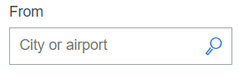  Rules:  1.2 The words ‘City or airport’ should be displayed in gray color inside the text box.  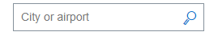  1.3 The text box should have a search glass like this for an ‘Airport lookup’.
REQ  2 | High | Input:  2.1 The user inputs a valid city name or an airport code in the text box.  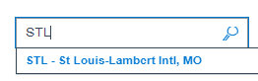  Rules:  2.2 The system should allow the user to enter a minimum of 3 to a maximum of 8 characters in this field.  2.3 This is a required field.  2.4 The system should allow the user to enter only alphabets.  2.5 When the user places cursor inside the ‘From’ text box, the system should highlight the box’s border in a blue color.    2.6 When the user starts to type in the text box the ‘City or airport’ disappear.  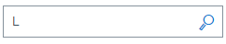  2.7 When the user clears/erases all that is typed in the text box the ‘City or airport’ Reappear.
REQ  3 | High | Input:  3.1 The user inputs the first three characters of a city name or an airport code.  Rules:  3.2 When the user inputs the first three characters of a city name or an airport code the system displays the list of all matching airports.  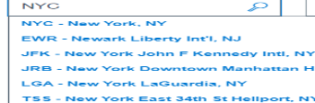  3.3 When the user hovers the cursor over an airport information, the system should highlight the airport information in blue color.  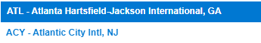  3.4 The system should display an US airport in the following format: <airport code>, <->, <airport name>, <,>, <state code>.  3.5 The system should display a US airport in the following format: <airport code>, <->, <airport name>, <,>, <country name>.  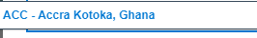  3.6 When the user clicks the airport information, The system displays the airport code in the text box.  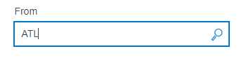
REQ  4 | High | Input:  4.1 The user clicks the search glass icon.  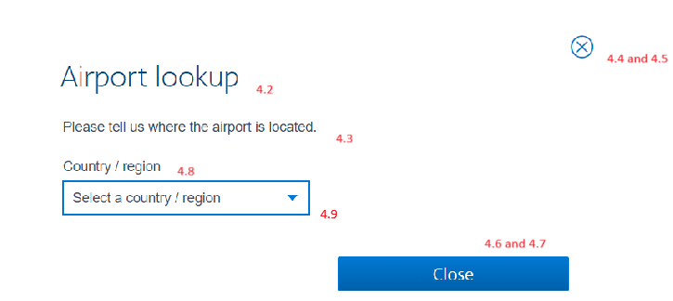  Rules:  4.2 When user clicks the search glass icon the system should display ‘Airport lookup’ window.  4.3 The system should also display ‘Please tell us where the airport is located’ beneath the ‘Airport Lookup’.  4.4 The system should also display the close icon.  4.5 When the user clicks the close icon the window should close.  4.6 The system should display this close icon as well.    4.7 When the user clicks the close icon the window should close.    4.8 The system should display the Country / region.  4.9 The system should display Select a country / region in a text box.    4.10 The system should display a drop-down icon  on the text box.  4.11 When the user clicks the drop-down icon, the system should display all Countries/ regions.  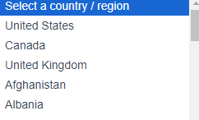  4.12 When the user hovers the cursor over a country/region information, the system should highlight in blue color.  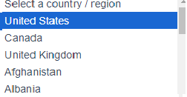
REQ  5 | High | Input:  5.1 The system should display ‘Number of Passengers’ label as displayed below.  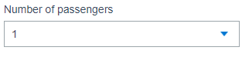  Rules:  5.2 The system should display a drop-down icon  on the right side of the text box.  5.3 When the user clicks the drop-down icon, the system should display the minimum ‘Number of passengers’ to select as 1 and the maximum should be 9.  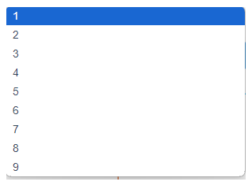  5.4 When the user hovers on the number of passengers to select from the drop-down, the system should highlight the selected number of passengers in blue color.  5.5 When the user clicks a number from the drop-down the system should display the selected number in the text box.  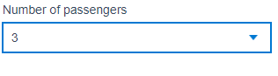  5.6 When the user clicks on the ‘Number of passengers’ text box, the system should highlight the box’s border in a blue color.  
REQ  6  REQ  7 | High  High | 6.1 The system should display ‘Depart’ label as displayed below  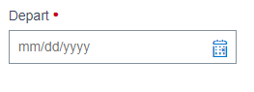  6.2 The system should display the month, day and year in this format ‘mm/dd/yyyy’ in gray color inside the text box.  6.3 The system should display a calendar icon like this  on the far-right side of the text box.  6.4 When the user clicks on the calendar icon, the system should display the calendar for the current month and the next month.  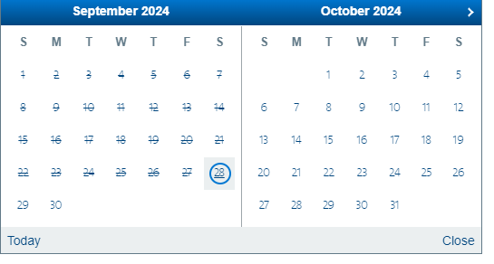  6.5 The system should display ‘Today’ on the bottom left of the Calendar for the current month and the next month.  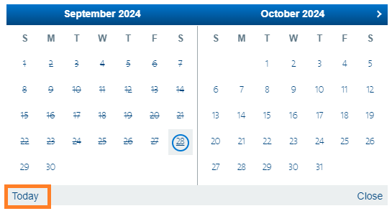  6.6 The system should display ‘Close’ on the bottom right of the Calendar for the current month and the next month.  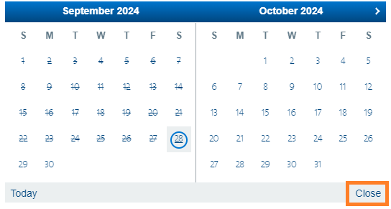  6.7 The system should underline the current day with blue color, highlight in grey color and with a blue circle.  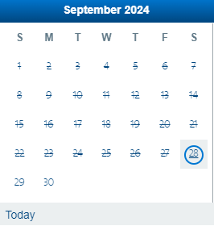  6.8 The system should display all the previous days as canceled excluding the current day and the subsequent days.  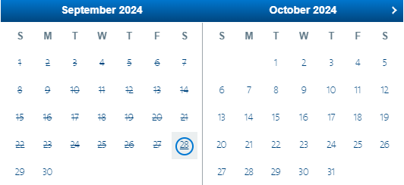  6.9 When the user clicks the Calendar icon, the system should display the current month up to the next 11 months.  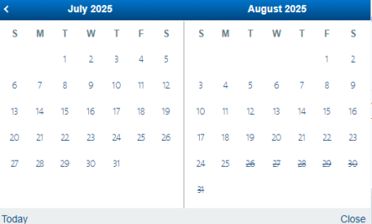  The Validation is triggered by either of the below actions:  7.1 The user presses the ’Enter’ key on the keyboard  Or  7.2 The user clicks the search button  
REQ  8 | High | Validation – “From Airport” will be validated by the system  Result of validation:  Normal Flow [If valid values are entered]  8.1 The system should display a list of all available flights  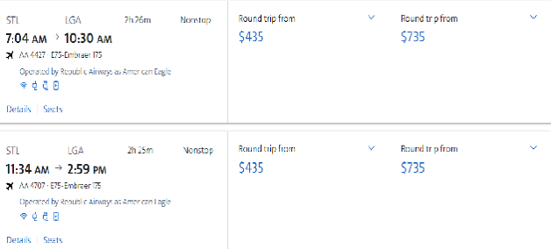  Exception Flow [If invalid values are entered]  8.2 When user leaves ‘From’ field blank, the system should highlight the text box in red indicating it as a required field and also indicate it as an error.  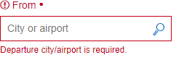  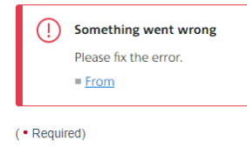  8.3 When a user enters an invalid value, the system should highlight the text box in red indicating the text box as a required field and also indicate the text box as an error.  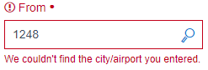  8.4 When the user enters values where the From and TO airport codes have the same value, the system should highlight both text boxes as red and indicate it as an error. The departure and arrival cities must be different.  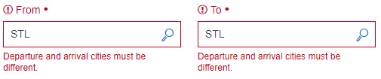  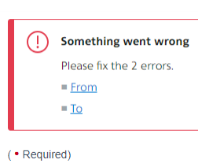

Minutes of the Meeting:
Host: Nandu Vaid
Attendees: Raphael Amanpene
Date: 9/25/2024
Time: 9:00 pm
Topic: User Requirements for ABC Airlines Booking Page
General Instructions:
Write the functional requirements of an airline booking page. Write about 6-7 lines for the purpose of the booking page and the document.
Requirement #1:
The system should display ‘From’ label as displayed below.
Requirement #2:
The user inputs a valid city name or an airport code in the text box.

Requirement #3:
The user inputs the first three characters of a city name or an airport code.
Requirement #4:
The user clicks the search glass icon.
Requirement #6:
The Validation is triggered by either of the below actions:

The user presses the ’Enter’ key on the keyboard
Or
The user clicks the search button

Requirement #7:
Normal Flow [If valid values are entered]
The system should display a list of all available flights
Exception Flow [If invalid values are entered]
When user leaves ‘From’ field blank then the text box should be highlighted in red indicating it as a required field also indicate it as an error

Classwork is copied below:
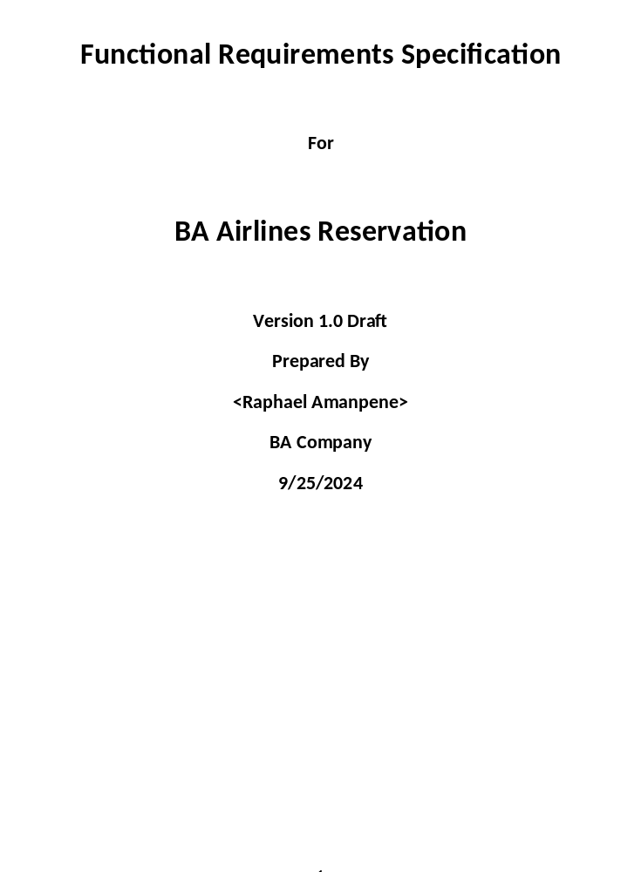 Guidelines for creating documents:
  - Simple English
  - No Spelling errors
  - No grammar errors
  - Proper formatting
  - Numbering
  - Upper case/lower case
  - Name for the document
  - Email subject line

Functional Requirements
SL No | Priority | Details
REQ  1 | High | Input:  - Create a ‘Vista Id’ label as displayed below.  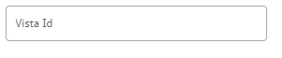
REQ  2 | High | Input:  2.1 The user should input a valid user id  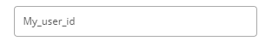  Rules:  2.2 The system should allow the user to enter a minimum of 8 to a maximum of 18 characters in this field.  2.3 This is a required field.  2.4 The system should allow the user to enter alpha and number values in this field.
REQ  3 | High | Input:  3.1 Create a ‘Password’ label as displayed below  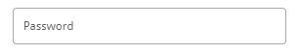

REQ  4 | High | Input:  4.1 The user should input a value in the text box.  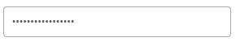  Rules:  4.2 The system should allow the user to enter a minimum of 8 to a maximum of 22 characters in this field.  4.3 This is a required field.  4.4 The system should allow the user to enter alpha, special and number values in this field.  4.4 The system should encrypt the password characters.
5 |  | Triggers the validation:  - The user clicks the ‘Sign In’ button.  Or  5.2 The user presses the “Enter Key”.  
Validation – Login Id and password should be validated by the system
Result of validation:
Normal Flow [If valid values are entered]
  - The system should log the user into his/her account and display the inbox.
Exception Flow [If invalid values are entered]
  - The system should display ‘Invalid value’.

